
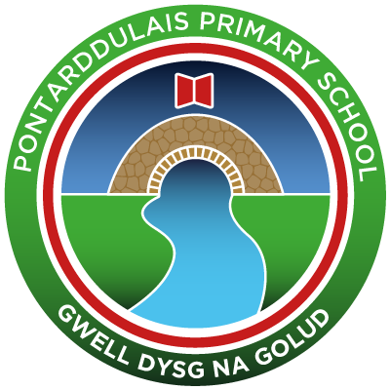
Pontarddulais Primary School
Home Learning
Use your Hwb account and associated programs to complete your work.
If you use Office 365 remember to share your work with your teacher. When using Just2Easy [J2e] remember to save your work for your teacher to
see in your, ‘My File Area’.
Year Group: Year 3 Date: 20.04.2020
AOLE | Challenge
Language Literacy and Communication |   Write a set of instructions on how you made your volcano. Include a title, a list of what you will need, numbered steps and connectives like, first, next, finally and include a labelled diagram.  Write a set of instructions on how you made your volcano. Include a title, sub-headings, numbered steps, connectives, bossy verbs and a labelled diagram.  Write a set of instructions on how you made your volcano. Include a title, sub-headings, numbered steps, connectives, bossy verbs and adverbs like, slowly, carefully. Add a labelled diagram.    

Health and Wellbeing | Take a daily walk around your garden or your neighbourhood with an adult.  Make a note of what you hear, see, smell and feel as you take in the nature that surrounds you.  Do you notice something you haven’t seen before?  Draw a picture or image of what you have seen and list what you have sensed, e.g. relaxed, calm, quiet.


AOLE | Challenge
Expressive Arts | Design a home that would support our needs during this time where we are at home.  Remember to label each section.  After designing it on paper, try creating your design on ‘Minecraft Education’ or making a model out of recycled materials.  (Minecraft is free to download from HWB)

Science and Technology | Make a rain gauge to measure rainfall?  Have a look at this website for some instructions and see how they measure it in cm’s using a ruler!  Take some photos and share them on Hwb.  We look forward to seeing some of your work.  ]


AOLE | Challenge
Mathematics and Numeracy | Using your rain gauge can you complete a table to measure the rainfall in cm over a week. Create a bar chart on J2e to record your findings.  Give the bar chart a title and label the axis with the days of the week and the amount of rainfall in cm.  Give the bar chart a title, label the axis and write a sentence about what the bar chart shows.  Give the bar chart a title, label the axis and write 3 sentences about what the bar chart shows you. Explain your reasons.

Humanities | Use the internet and an atlas to locate places in Wales that have been flooded. List these places and write down the impact these floods have had on people living there e.g. Have they lost their homes? How do you think they have felt?  Use the internet and an atlas to locate places in the UK that have been flooded. List these places and write down the impact these floods have had on people living there  Use the internet and an atlas to locate places in the world that have been flooded. List the places and write down the impact theses floods have had on people living there.



Article 28: You have the right to a good quality education and your education should help you use and develop your talents and abilities.

