Write the time shown on each clock.

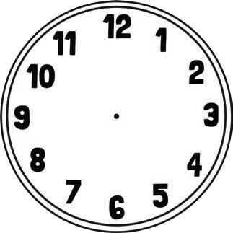

Draw the time on each clock.

9 o’clock half past 3 5 o’clock 1 o’clock

half past 7 half past 8 10 o’clock half past 12

11 o’clock half past 4 half past 6 2 o’clock

