Tell the Time: Writing the Time

Write the time shown on each clock.

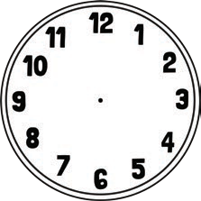
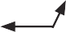

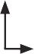




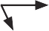
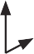



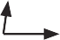


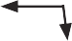



Tell the Time: Drawing the Time

Draw the time on each clock.

9 o’clock half past 3 6 o’clock half past 4 quarter past 2 half past 1

quarter to 11 11 o’clock half past 2 5 o’clock quarter past 1 half past 5

quarter to 8 3 o’clock half past 6 quarter to 1 half past 7 quarter past 8

10 o’clock half past 12 quarter past 11 quarter to 4 half past 6 2 o’clock

