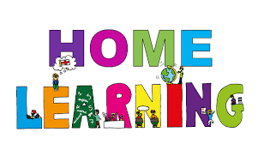
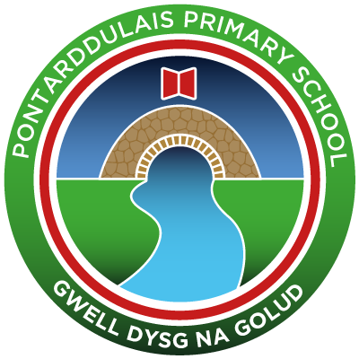
Pontarddulais Primary School
Home Learning
Use your Hwb account and associated programs to complete your work.
If you use Office 365 remember to share your work with your teacher. When using Just2Easy [J2e] remember to save your work for your teacher to
see in your, ‘My File Area.’
Year Group: Year 3 Date: 29.06.2020 Theme: Global Gourmet
AOLE | Challenge
Language Literacy and Communication |       Are you ready to be challenged?  - Log into Hwb  - Click on J2blast  - Click on Ttblast and have a go at the spelling words…  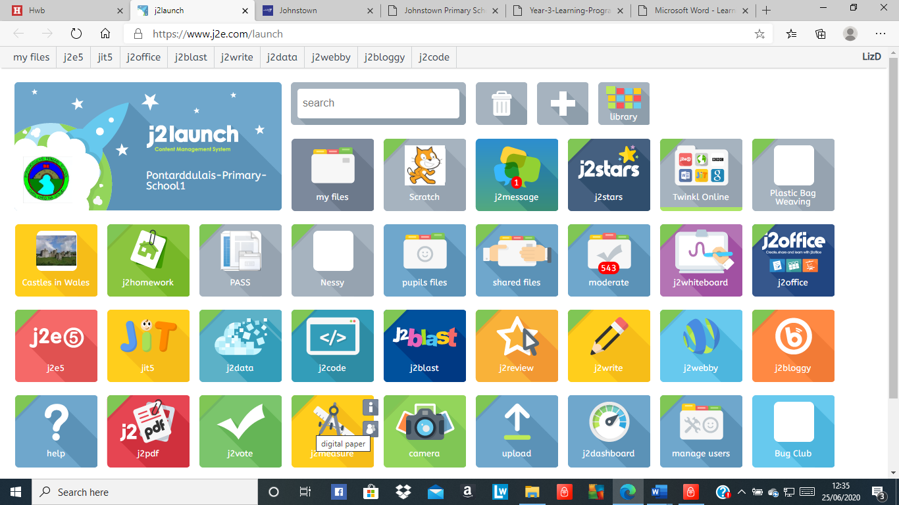  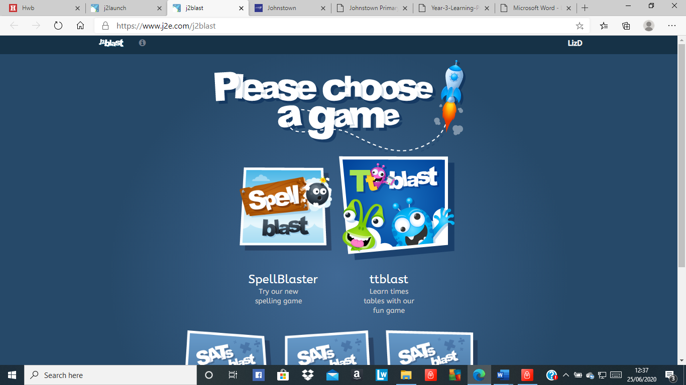
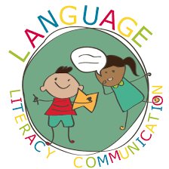
Health and Wellbeing | Create your very own outdoor/indoor obstacle course to complete.  - Think about how challenging you will make it.  - Think about how long it will take you to complete.  - Think about how you can make it harder for your  older brother/sister/adults  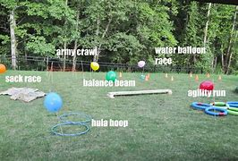
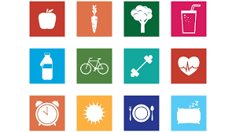

AOLE | Challenge
Expressive Arts | 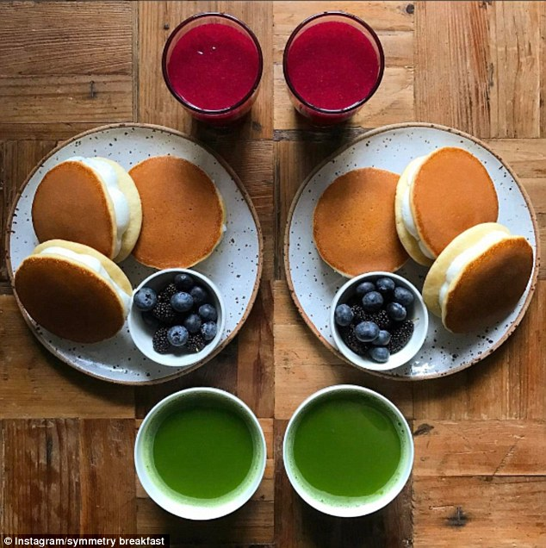  Symmetry  A 2D shape is symmetrical if a line can be drawn through it so that either side of the line looks exactly the same.  The line is called a line of symmetry. This is sometimes called a 'mirror line' or 'mirror symmetry', because if you put a mirror on the line, the reflection would show the whole shape.  Can you have a go at making food symmetry!  Don’t forget to upload your images to J2e!

Science and Technology | Spaghetti Challenge: Spaghetti bridge that will hold a bag of sugar!  Watch the following video https://www.youtube.com/watch?v=Pp9U6lyoIqg  Then have a look at the Dyson website for the challenge card containing instructions  https://www.jamesdysonfoundation.com/resources/challenge-cards.html  OR create your own design!  Upload your design to j2e. Then, you could film/photograph your results and upload them to your Hwb account. If you enjoy this task, look at some of the other fun and exciting design activities on the dyson website and have a go at them!


AOLE | Challenge
Mathematics and Numeracy | Are you ready to be challenged?  - Log into Hwb  - Click on J2blast  - Click on Spellblast and have a go  at the spelling words…  You can compete with your friends!
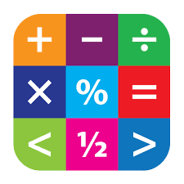
Humanities | Can you research which foods were introduced to Britain, by whom and when?  For example:  - The Tudors (tomatoes, potatoes, chocolate)  - The Victorians (tropical foods)  - More recent immigrants to Britain  Finally, can you decide from a food point of view, which would be the best period of history to live in, apart from today?
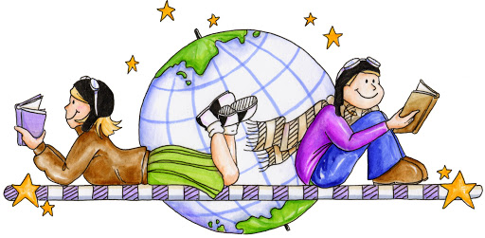

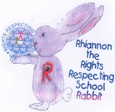
Article 28: You have the right to a good quality education and your education should help you use and develop your talents and abilities.

