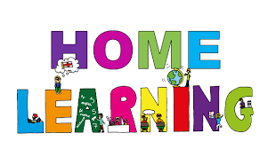
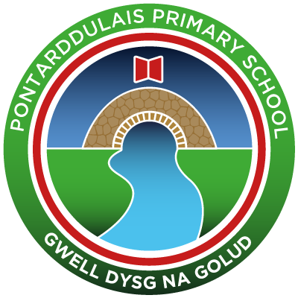
Pontarddulais Primary School
Home Learning
Use a workbook or your Hwb account and associated programs to complete your work.
If you use Office 365, remember to share your work with your teacher.
When using Just2Easy [J2e] remember to save your work for your teacher to see in your ‘My File Area’.
Year Group: Year 2 Date: 6.7.20 - 10.7.20
AOLE | Challenge
Language Literacy and Communication |       Read the power point about Andy Goldsworthy (shared files)  Discuss the questions on the power point.  Write three facts that you found out about Andy Goldsworthy.  .  Spelling- Can you practise your spelling using J2blast.  Look on the J2launch pad and click on J2blast spelling.  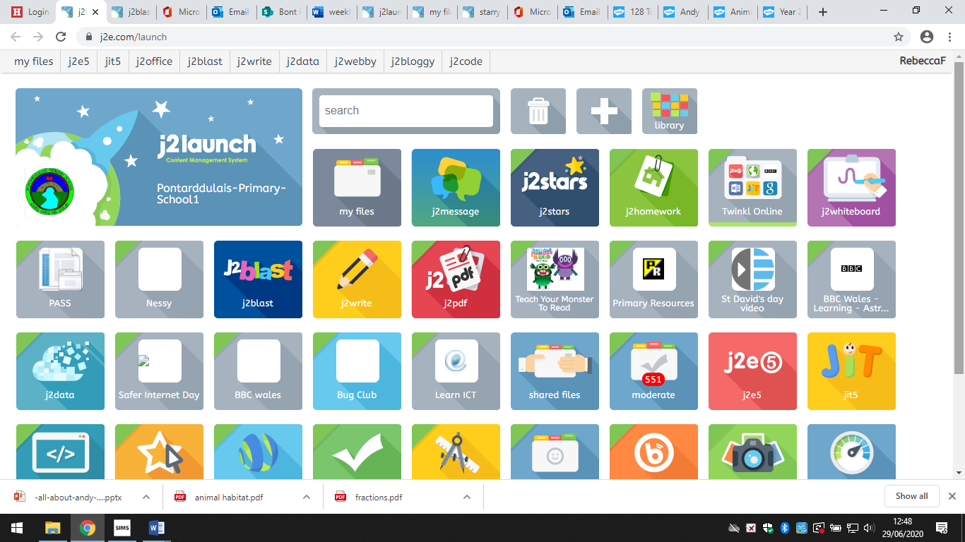
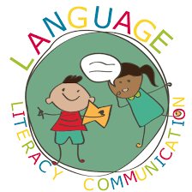
Health and Wellbeing | It is so important that we look after our environment.  Make a poster or set of rules (you can draw/write or use JIT Mix)  to encourage people to look after their local park/woodland.


AOLE | Challenge
Expressive Arts | Create a collage/sculpture in the style of Andy Goldsworthy.  You can use any natural materials to create your sculpture.  Remember to share your pictures with us on hwb and twitter!

Science and Technology | Read the power point ‘Natural and man-made materials’  Complete the man-made or natural sorting activity (shared files)


AOLE | Challenge
Mathematics and Numeracy | Complete the fractions worksheet (shared files)  Visit the topmarks website, search for fractions.  Play the fraction game (aged 5 to 7)  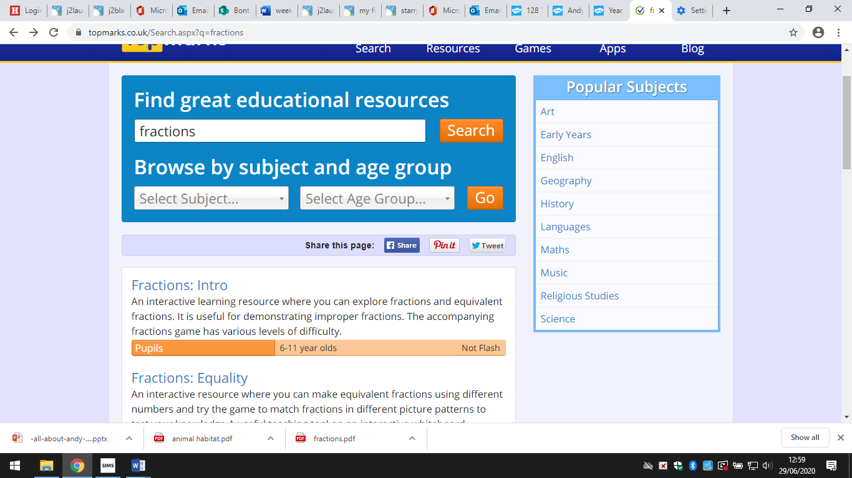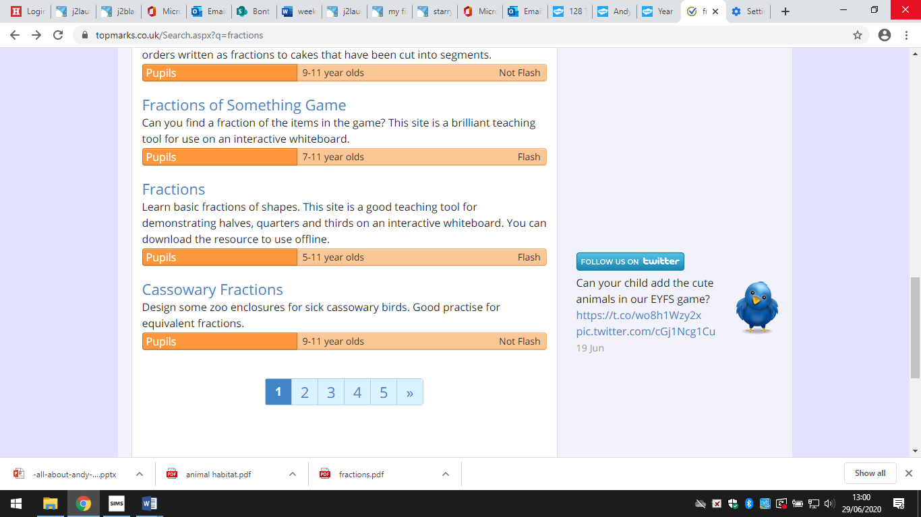  Challenge: Make a cake or pizza and cut it into half, quarters.
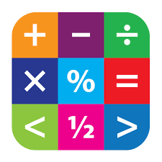
Humanities | Go on a walk to your local woodland.  Use the worksheet ‘animal habitat’ on shared files  to write about your chosen woodland animal.


Remember – How you complete your challenges is your choice. If you would like to show us
your work via Hwb we would love to see it.
We loved seeing you back in school last week, keep working hard.
Love from Mrs Findlay and Mrs Thomas 😊

