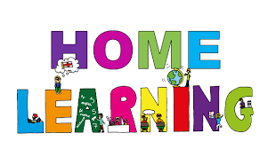

Pontarddulais Primary School
Home Learning
Use a workbook or your Hwb account and associated programs to complete your work.
If you use Office 365, remember to share your work with your teacher.
When using Just2Easy [J2e] remember to save your work for your teacher to see in your ‘My File Area’.
Year Group: Year 2 Date: 29.6.20 - 3.7.20
AOLE | Challenge
Language Literacy and Communication |       Listen to the story ‘Lost on the beach’ by Ian Beck .- See you tube video.  Discuss the story together- What was your favourite part?  Sequence the story, What happened in the beginning, middle, end?  Design a safety poster to keep yourself and others safe when visiting the beach.  Consider, sun scream, stay with an adult, swim between the flags etc.  Design poster templates are available to Print or download in shared files (see summer safety poster) or create your own.  .  Spelling- How many words can you find that rhyme with:  Hat, tide, sand, sea, shell hut. (See seaside rhyming words worksheet in shared files)
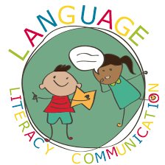
Health and Wellbeing | Read the power point ‘Starry eyed Stan friendship’ in shared files.  Discuss the power point, what makes a good friend?  Create a list of qualities that make a good friend.  (Starry eyed Stan friendship template available to use if you want – shared files)


AOLE | Challenge
Expressive Arts | Create a seaside craft of your choice.  Be creative, use any resources you wish and share your creations on hwb.

Science and Technology | Use JIT paint to create a beach picture.  Use the underwater stamps and beach template.


AOLE | Challenge
Mathematics and Numeracy | Complete 1 of the multiplication wheel sheets (shared files)  Play the ‘hit the button game’ on topmarks.  Practise 2, 5 and 10 times tables.  Challenge: Complete the Starry eyed Stan  multiplication colouring puzzle. (shared files)
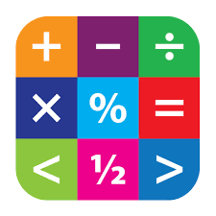
Humanities | Read the power point ‘Seaside holidays now and then’ in shared files.  Sort the picture into the correct place on the table (Comparing the seaside sheet –shared files)


Remember – How you complete your challenges is your choice. If you would like to show us
your work via Hwb we would love to see it.
We are looking forward to seeing you back at school next week. For those of you not returning, keep working hard on your challenges at home.
Love from Mrs Findlay and Mrs Thomas 😊

