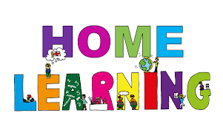

Pontarddulais Primary School
Home Learning
Use a workbook or your Hwb account and associated programs to complete your work.
If you use Office 365, remember to share your work with your teacher.
When using Just2Easy [J2e] remember to save your work for your teacher to see in your ‘My File Area’.
Year Group: Year 2 Date: 21.6.20 - 25.6.20
AOLE | Challenge
Language Literacy and Communication |       Read your favourite bedtime story and complete a book review about the book  (print or download the review template in shared files)  If you like, you can record a short video telling us about your favourite  story and upload it for us to see on hwb.  For your mathematics challenge you had been asked to create potion to help Plop sleep. Can you write a set of instructions explaining how you made it e.g. Pour in 20ml of muddy water.  Remember to use bossy verbs and numbered steps.  Spelling- How many words can you write with the spelling pattern ‘ing’? e.g mixing, running  Now choose three words and write a sentence using each word.  Visit the following site for further phonic ideas:  www.ruthmiskin.com/en/find-out-more/parents
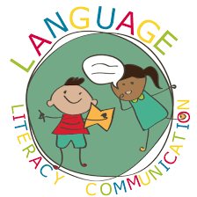
Health and Wellbeing | In the story, Plop is afraid of the dark.  Can you design a poster with some tips on how to get to sleep at night.  Think about sharing some things from your bedtime routine  e.g Have a warm drink, a nice hot bubble bath, read a bedtime story.


AOLE | Challenge
Expressive Arts | Can you make your very own dream catcher?  You could use wool, string, paper, sequins etc to decorate it too!  Have a look online for some inspiration!

Science and Technology | Use JIT animate to create a short animation of your favourite bedtime story.


AOLE | Challenge
Mathematics and Numeracy | Have a look at different containers that hold liquid around your home e.g. milk, pop, washing up liquid etc.  Can you order the containers from least to most amount of liquid?  Download or print the worksheet in shared files.  Can you measure different containers to see if they hold more  or less than a litre?  Challenge: See teams for a special video from your teacher about this challenge.  Can you make a potion to help Plop sleep?  Include different amounts of liquids and objects  e.g 50ml muddy water, 10ml washing up liquid, 20ml coloured water. 1 sprinkle of magic sleeping dust (glitter), 5 stones, 6 small sticks. Be as adventurous as you like!
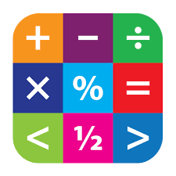
Humanities | Choose your favourite animal and find out about where it comes from  and it’s habitat.


Remember – How you complete your challenges is your choice. If you would like to show us
your work via Hwb we would love to see it.
Keep working hard and enjoy your new challenges.
Love from Mrs Findlay and Mrs Thomas 😊

