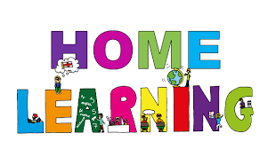

Pontarddulais Primary School
Home Learning
Use a workbook or your Hwb account and associated programs to complete your work.
If you use Office 365, remember to share your work with your teacher.
When using Just2Easy [J2e] remember to save your work for your teacher to see in your ‘My File Area’.
Year Group: Year 2 Date: 8.6.20 - 15.6.20
AOLE | Challenge
Language Literacy and Communication |       Read chapter 7 of ’The Owl who was afraid of the dark.  This chapter is called dark is beautiful and is the final chapter for the book.  Can you create a matching game like pairs that matches the character to what  they learnt about the dark e.g old lady = dark is kind/memories.  Can you make a storyboard summarising each chapter of the story.  Spelling- How many words can you write with the spelling pattern ‘i-e’? e.g mine, time  Now choose three words and write a sentence using each word.  Visit the following site for further phonic ideas:  www.ruthmiskin.com/en/find-out-more/parents  Check out the magic e song on youtube.
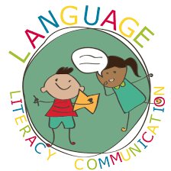
Health and Wellbeing | Search for ‘cosmic kids yoga’ and enjoy following Parsnip the cat yoga session.


AOLE | Challenge
Expressive Arts | Can you make a collage or piece of art work showing your favourite chapter in the story?

Science and Technology | Use JIT mix to draw a picture of the cat character and type  some sentences explaining how he helped Plop.


AOLE | Challenge
Mathematics and Numeracy | Revise the names and properties of 3d shapes  (see twinkl for printable worksheets )  Can you use 3d shapes around your home to create a 3D model? E.g. house, rocket, robot.  Go on a 3d shape hunt around your home. Can you record your results on a tally chart  and use JIT chart program to record what you found?

Humanities | The cat takes Plop up to the rooftops to see where he lives.  Plop thinks it is wonderful. Can you research the place that you live and tell us about it?  Perhaps you could go for a walk and list the things you see/ make a poster/leaflet.


Remember – How you complete your challenges is your choice. If you would like to show us
your work via Hwb we would love to see it. Keep working hard and enjoy your new challenges. Don’t forget to look in your class ‘ teams’ page to find a special message of your teachers.
Love from Mrs Findlay and Mrs Thomas 😊

