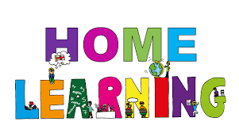
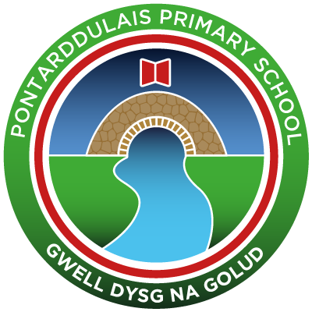
Pontarddulais Primary School
Home Learning
Use a workbook or your Hwb account and associated programs to complete your work.
If you use Office 365, remember to share your work with your teacher.
When using Just2Easy [J2e] remember to save your work for your teacher to see in your ‘My File Area’.
Year Group: Year 2 Date: 1.6.20 - 5.6.20
AOLE | Challenge
Language Literacy and Communication |       Listen to the video of your teacher reading Chapter 6 (Teams page).  This chapter is all about star gazing. Can you research to find out about other stars.  Find out about the planets in our solar system and make an  information poster about your favourite one.  Spelling- How many words can you write with the spelling pattern ‘a-e’? e.g made, spade  Now choose three words and write a sentence using each word.  Visit the following site for further phonic ideas:  www.ruthmiskin.com/en/find-out-more/parents  Check out the magic e song on youtube.
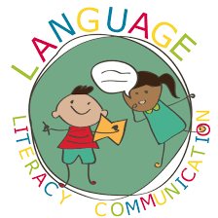
Health and Wellbeing | Cwtch up with your family and stay up until it gets dark to see what stars you can spot.  Draw a picture or take some photographs to share with us!
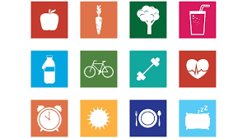

AOLE | Challenge
Expressive Arts | This is chapter is all about stars, can you wish upon a star and make your own ‘wishing jar’.  Decorate a jar with lots of sparkly materials and write your wishes to put inside.  Your wishes could be things you would like to do after lockdown is over.

Science and Technology | Can you make a space themed model or collage?  Perhaps you could make a planet, a rocket, spaceship, star mobile etc.


AOLE | Challenge
Mathematics and Numeracy | Revise the names and properties of 2d shapes  (see twinkl for printable worksheets )  Go to J2E then J2code, click on the year 1 /2 lesson plans  and follow the lesson plan for lesson 1 ‘rocket.’  Design a rocket using 2d shapes, label what shapes you have used.
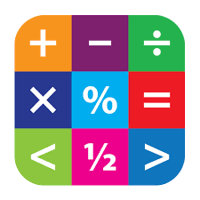
Humanities | Draw and label your own compass showing North, South, East and West.  Make your own way of remembering these e.g Never eat shredded wheat.


Remember – How you complete your challenges is your choice. If you would like to show us
your work via Hwb we would love to see it. We hope you had a little rest over Half Term. Keep working hard and enjoy your new challenges. Don’t forget to look in your class ‘ teams’ page to find a special message of your teachers.
Love from Mrs Findlay and Mrs Thomas 😊

