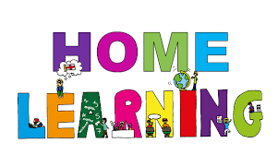
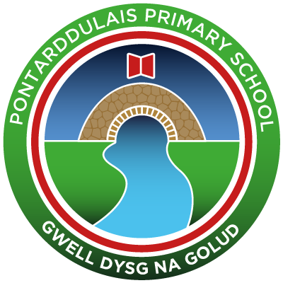
Pontarddulais Primary School
Home Learning
Use a workbook or your Hwb account and associated programs to complete your work.
If you use Office 365, remember to share your work with your teacher.
When using Just2Easy [J2e] remember to save your work for your teacher to see in your ‘My File Area’.
Year Group: Year 2 Date: 18.5.20 - 22.5.20
AOLE | Challenge
Language Literacy and Communication |       Read the fourth and fifth chapters of the story ’The Owl who was afraid of the dark’  Comprehension – Can you answer the following questions:  - Who does Plop meet in these chapters?  - What do the people tell him about the dark?  - Use a dictionary to find out the meaning of ‘necessary’ and ‘fascinating’  The lady in chapter 5 draws lots of different nocturnal animals.  Can you create a fact file about a nocturnal animal of your choice?  Spelling- How many words can you write with the spelling pattern ‘aw’? e.g saw, claw  Now choose three words and write a sentence using each word.  Visit the following site for further phonic ideas:  www.ruthmiskin.com/en/find-out-more/parents
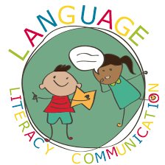
Health and Wellbeing | To make sure your getting plenty of daily exercise, can you design either your own obstacle course in your garden or your own fitness workout. E.g 5 x star jumps, 5 x burpees.  Perhaps you could share these with your teachers, they might even give it a go!  If you wish you can also share these on the school twitter page.


AOLE | Challenge
Expressive Arts | In this chapter the lady is an artist and draws lots of different nocturnal animals.  Can you draw a nocturnal animal of your choice.  Perhaps you could experiment with different media e.g pencils, pens, charcoal, paint, pastels?

Science and Technology | Online there are a selection of experiments using eggs,  have a look and choose one you would like to try. Here's one as an example:  https://www.bluebearwood.co.uk/dissolving-expanding-and-bouncing-eggs/  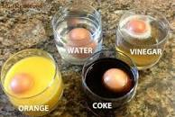


AOLE | Challenge
Mathematics and Numeracy | Revise all coins up to £2, order the coins in value.  Add amounts of coins up to £1.  (see twinkl for printable worksheets )  Play the ‘toy shop’ game on the ‘topmarks’ website  to practise money.  www.topmarks.co.uk  Create your own shop role play, practise using money to buy items and give change.  (Items up to £1 and giving change in multiples of 10)
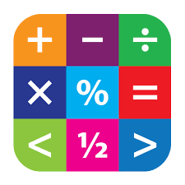
Humanities | When Plop’s Mum and Dad fly they look down, this is called a ‘bird’s eye view’.  Can you draw a birds eye view of your bedroom or garden. Remember to label your plan.


Remember – How you complete your challenges is your choice. If you would like to show us
your work via Hwb we would love to see it.
Keep working hard, we are really enjoying seeing all your lovely challenge work.
Love from Mrs Findlay and Mrs Thomas 😊

