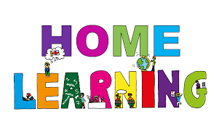

Pontarddulais Primary School
Home Learning
Use a workbook or your Hwb account and associated programs to complete your work.
If you use Office 365, remember to share your work with your teacher.
When using Just2Easy [J2e] remember to save your work for your teacher to see in your ‘My File Area’.
Year Group: Year 2 Date: 11.5.20 - 15.5.20
AOLE | Challenge
Language Literacy and Communication |       Read the third chapter of the story ’The Owl who was afraid of the dark’  (see PDF document in pupil folder)  In the first two chapters Plop goes out and meets different people and they tell him things about the dark. Can you predict what will happen in the next chapter? Who will he meet? What will they tell him?  Can you design an information leaflet about owls?  Perhaps you could use subheadings, such as, appearance, habitat, food etc  Spelling- How many words can you write with the spelling pattern ‘ai’? e.g rain, sail  Now choose three words and write a sentence using each word.  It rained a lot this week.  Visit the following site for further phonic ideas:  www.ruthmiskin.com/en/find-out-more/parents
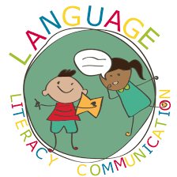
Health and Wellbeing | In the story Plop is afraid of the dark.  Can you write about a time you felt afraid and describe what you did to overcome your fear?


AOLE | Challenge
Expressive Arts | In this chapter the Boy scouts sing songs around the campfire.  Can you find some campfire songs and enjoy performing them.  Perhaps you could make a pretend campfire and role play camping in your garden!

Science and Technology | Can you design a nest?  You could use any materials you wish, E,g twigs and natural materials from your garden or you might want to be inventive and use other arts and crafts materials of your choice!


AOLE | Challenge
Mathematics and Numeracy | Practise adding a one digit number to a 2 digit number by counting on.  Perhaps you can challenge yourself by adding a 2 digit number to a 2 digit number by using a 100 square to add the tens and then units.  (see twinkl for printable worksheets and 100 square)  Play the ‘mental maths train’ game on the ‘topmarks’ website  to practise addition.  www.topmarks.co.uk  Write your own addition word problems.  E.g Plop brought home six worms and his dad brought home 15 voles,  How many things did Plop have to eat that day?

Humanities | Last Friday people celebrated V.E day.  Can you find out three facts about World War 2?


Remember – How you complete your challenges is your choice. If you would like to show us
your work via Hwb we would love to see it.
You are all working so hard. We miss you very much, but for now keep enjoying learning at home and stay safe. Love from Mrs Findlay and Mrs Thomas 😊

