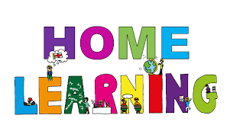

Pontarddulais Primary School
Home Learning
Use a workbook or your Hwb account and associated programs to complete your work.
If you use Office 365, remember to share your work with your teacher.
When using Just2Easy [J2e] remember to save your work for your teacher to see in your ‘My File Area’.
Year Group: Year 2 Date: 20.4.20 - 24.4.20
AOLE | Challenge
Language Literacy and Communication |       Write or type a letter to your friend or teacher,  telling them what you have been doing during your time at home.  If you would like us to read it make sure you save it to HWB!  Read your favourite book, write / type a review about the book.  How many stars would you give it? What was your favourite part / character?  Spelling- How many words can you write with the spelling pattern ‘igh’?  e.g fright, sight  Now choose three words and write a sentence using each word.  I had a fright when I saw a shadow.
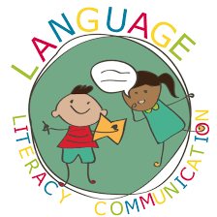
Health and Wellbeing | Try making a healthy snack,  This could be a smoothie, fruit kebab, fruit salad.  If you can, take a photo and upload it onto HWB for your teachers to see all your delicious ideas.


AOLE | Challenge
Expressive Arts | Use your artistic skills to make a rainbow picture!  Ideas could include using paint, fruit, hwb paint, natural materials, fabric, chalk  Hwb Heroes- Check out our school Twitter page for the video from Kirsty Williams (Education Minister)  asking for your help in creating a poem, song, picture to share with others to make them smile.  https://hwb.gov.wales/HwbHeroes

Science and Technology | Make a chart to record the daily weather. Draw a picture and write a sentence.  Maybe you could do this in Welsh.  E.g. Mae hi’n heulog, Mae hi’n bwrw glaw.


AOLE | Challenge
Mathematics and Numeracy | Practise your 2 times table,  Can you say them to your family? Can you write them down?  Can you say them out of order?  Play ‘Hit the button’ and ‘Coconut Multiples’ games on the Topmarks website  to practise your 2 times table.  www.topmarks.co.uk  Can you solve the 2 times table problems below?  Charlie the rabbit eats 2 juicy carrots every day,  How many carrots does he eat in 4 days? 6 days? Etc.

Humanities | Make a map of your local area.  Remember to record all the main features such as schools, churches, shop etc  Colour your map and label it neatly.


Remember – How you complete your challenges is your choice. If you would like to show us
your work via Hwb we would love to see it. We are missing you all and can’t wait to see you when we return to school.
Stay Safe love from Mrs Findlay and Mrs Thomas 😊

