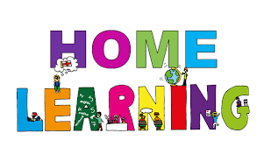

Pontarddulais Primary School
Home Learning
Use a workbook or your Hwb account and associated programs to complete your work.
If you use Office 365, remember to share your work with your teacher.
When using Just2Easy [J2e] remember to save your work for your teacher to see in your ‘My File Area’.
Year Group: Year 2 Date: 4.5.20 - 8.5.20
AOLE | Challenge
Language Literacy and Communication |       Read the second chapter of the story ’The Owl who was afraid of the dark’  (see PDF document in pupil folder)  Use your visualisation skills to imagine and then draw a scene from the chapter.  The second chapter is all about memories.  Can you write about the memories you are making with your family during this time?  Spelling- How many words can you write with the spelling pattern ‘ee’? e.g feet, week  Now choose three words and write a sentence using each word.  I watered my plants this week.  Visit the following site for further phonic ideas:  www.ruthmiskin.com/en/find-out-more/parents
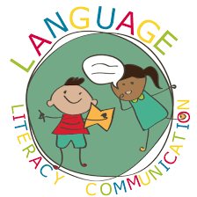
Health and Wellbeing | As chapter two is all about memories, can you test your memory by playing ‘Kim’s game?’  Kim’s Game- Place 10 items on a tray, look at the items and try to memorise them.  Ask an adult to cover the items with a towel and remove one item without you seeing.  Can you write or draw what item is missing?  Perhaps you could challenge yourself and remove more than one item at a time?


AOLE | Challenge
Expressive Arts | Make an owl themed craft of your choice.  Perhaps you could use junk material, fabric to make a collage, natural material?

Science and Technology | This term we would have been learning about life cycles at school.  Can you find out about the life cycle of a frog? Present your work however you want.  There are lots of resources on twinkl about this.


AOLE | Challenge
Mathematics and Numeracy | Practise subtracting a one digit number from a 2 digit number by counting back.  Perhaps you can challenge yourself and subtract a 2 digit number from a 2 digit number by using a 100 square to take away the tens and then units.  (see twinkl for printable worksheets and 100 square)  Play ‘Subtraction grids’ game on the ‘topmarks’ website  to practise subtraction.  www.topmarks.co.uk  Write your own subtraction word problems.  E.g Mum baked 18 cookies, my brother ate 6 of them. How many are left?

Humanities | The old lady in the story loved remembering her family.  Make a video call to an older member of your family.  Can you find out 3 things about their childhood?  E.g games they played? Favourite meals? Chores etc?


Remember – How you complete your challenges is your choice. If you would like to show us
your work via Hwb we would love to see it.
Looking at all your pictures and work makes us smile, keep enjoying learning at home with your family. Love from Mrs Findlay and Mrs Thomas 😊

