Vincent Van Gogh | 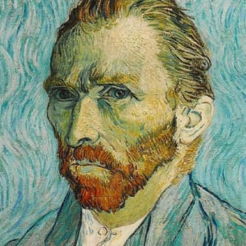
Date of birth: | 1853
Age: | 37
Number of paintings (est.): | 2,000
Highest Value Painting:  Fame Rating  (out of 10): | £60,500,000  8
William Morris | 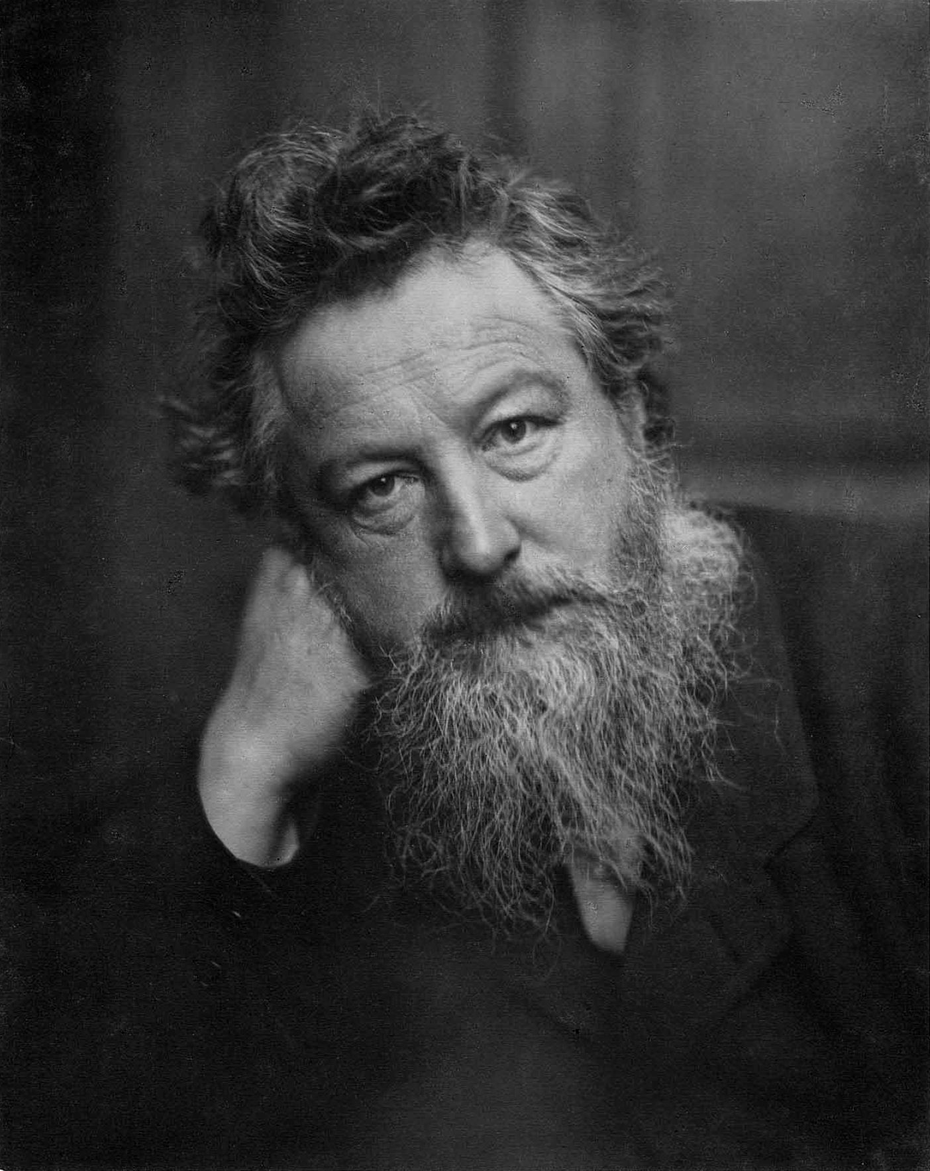
Date of birth: | 1834
Age: | 62
Number of paintings (est.): | 41,000
Highest Value Painting:  Fame Rating (out of 10): | £4,000  4
Claude Monet | 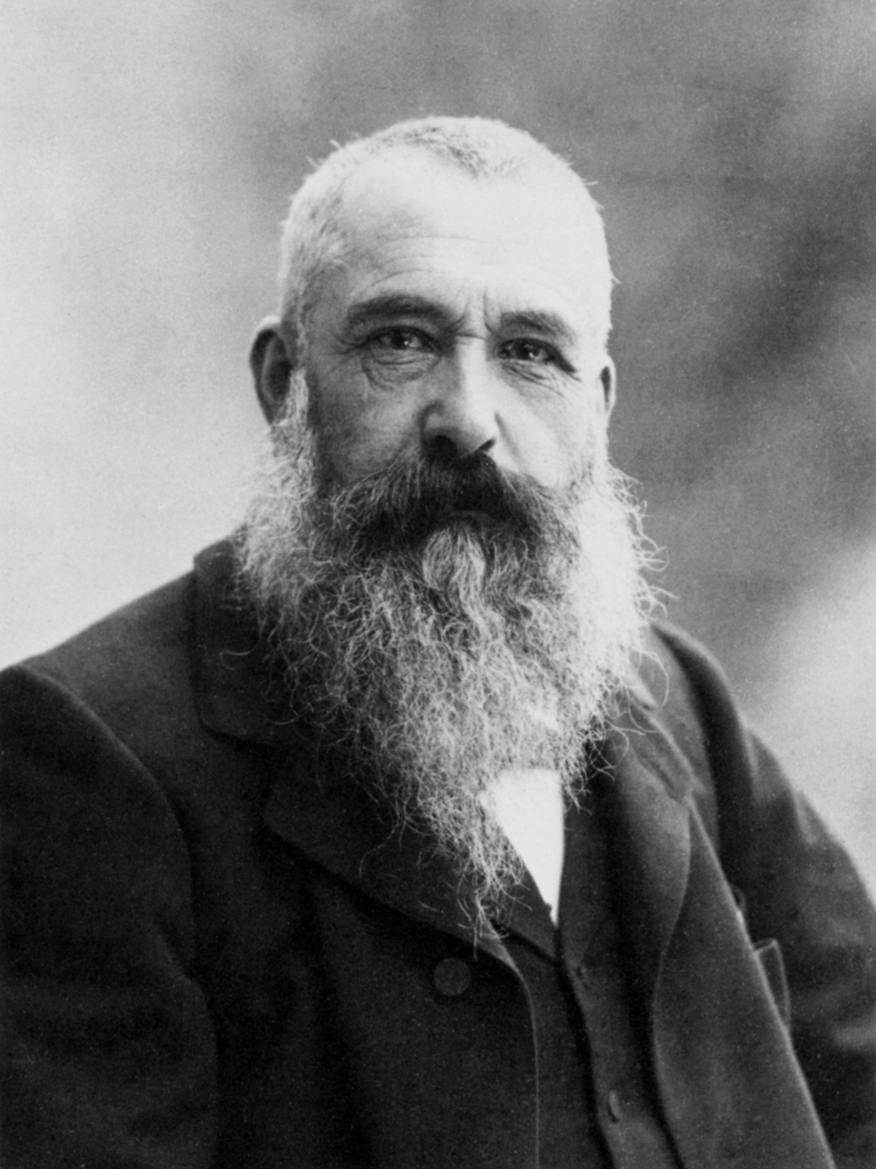
Date of birth: | 1840
Age: | 86
Number of paintings: | 2,000
Highest Value Painting:  Fame Rating (out of 10): | £59,000,000  6

Paul Klee | 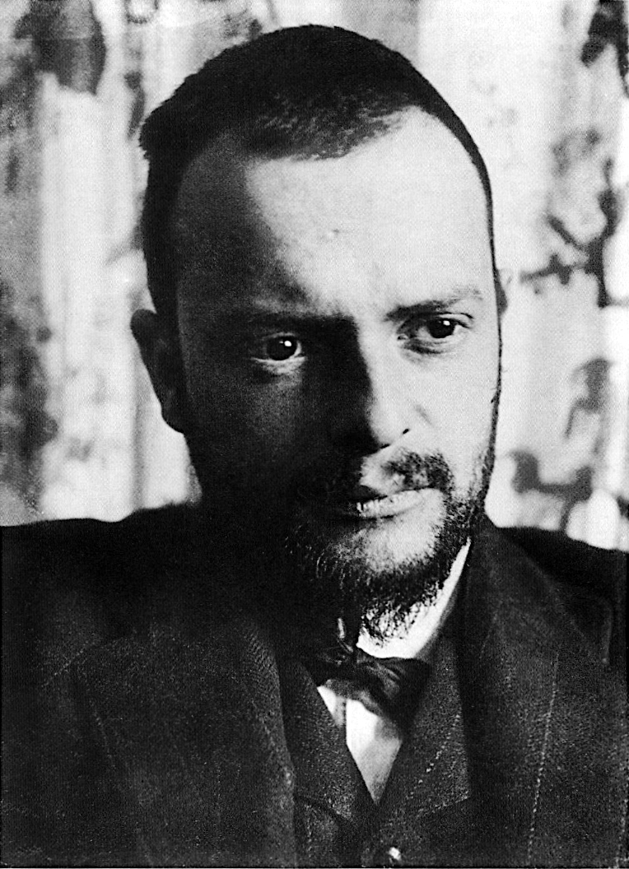
Date of birth: | 1879
Age: | 60
Number of paintings: | 10,000
Highest Value Painting:  Fame Rating (out of 10): | £4,900,000  3
Banksy | 
Date of birth: | 1973
Age: | 47
Number of paintings (est.) | 131
Highest Value Painting:  Fame Rating (out of 10): | £8,900,000  7

Dorian Spencer Davies | 
Date of birth: | 1960
Age: | 60
Number of paintings: | 150
Highest Value Painting:  Fame Rating (out of 10): | £3,000  2

Henri Matisse | 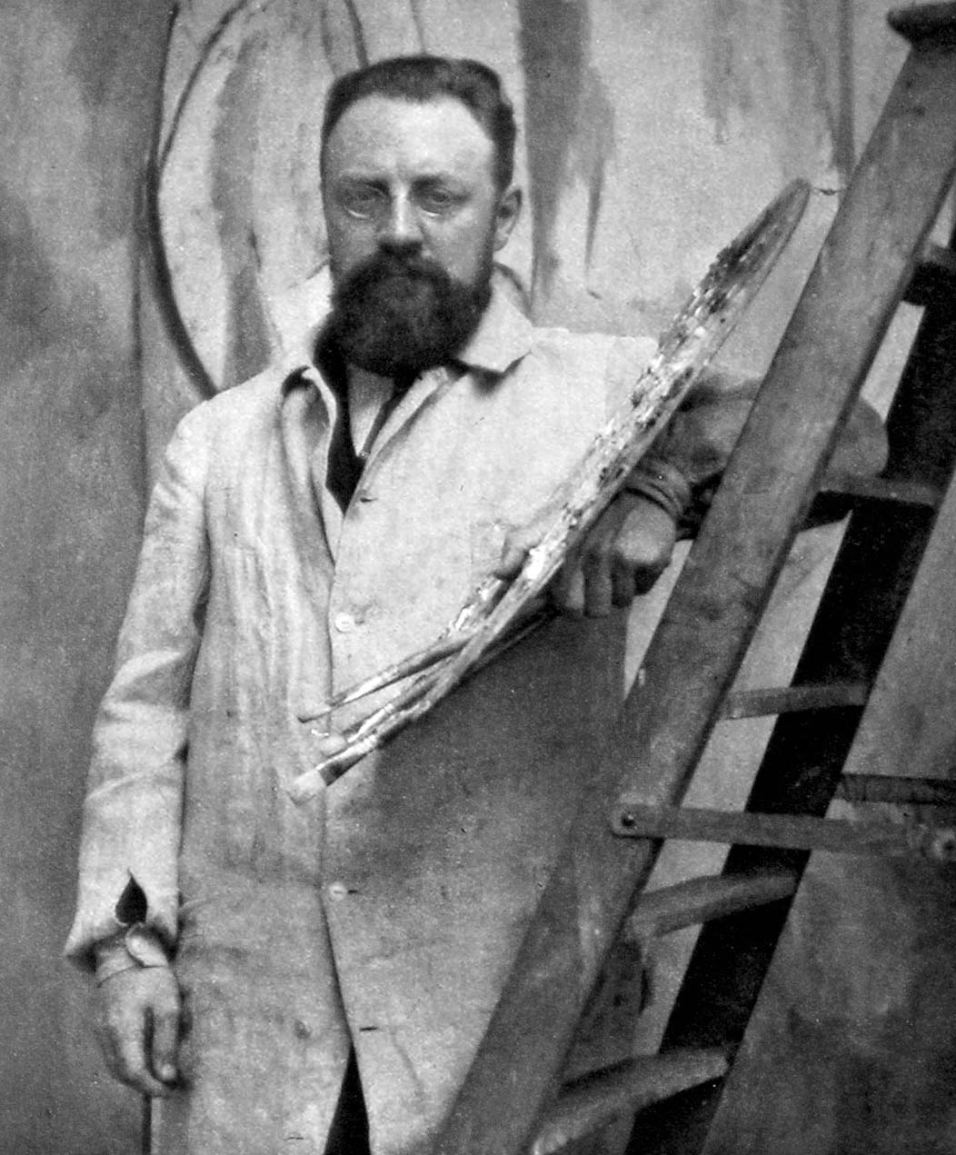
Date of birth: | 1869
Age: | 84
Number of paintings (est.): | 1,008
Highest Value Painting:  Fame Rating (out of 10): | £59,000,000  3

Questions

- Find the Mean, Median, Mode and Range for the artist’s fame ratings.
- Find the Mean and Range for the artist’s ages.
- Find the Median of the artist’s date of birth.
- Find the Median and Mode of the artist’s highest value painting.
- Find the Mean, Median, Mode and Range for the number of paintings that the artists have done.

Rules of Artist Top Trumps

Date of birth: Most recent date wins.
Age: Oldest artist wins.
Number of paintings: Most paintings wins.
Highest Value Painting: Highest value wins.
Fame Rating: Highest fame rating wins.

