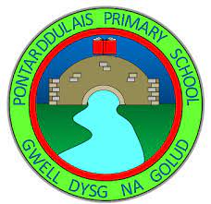
Welcome to September 2023 – Nursery AM

We are all ready for the exciting new half term. Here is some information for you to start the half term.
Topic
For the next few weeks our topic will be Marvelous me!
We are looking forward to learning all about ourselves and our families.
Twitter
We tweet pictures of our children in Nursery joining in with our class activities and exploring the areas of the classroom.
@PontarddulaisSc
Information
Our morning times are 8.50am-11.20am.
Our PE session will be on a Tuesday morning. Please can the children come dressed in suitable clothes for PE including trainers.
Milk – we will continue to have milk every morning provided by the school.
Parents meetings
This term parents meetings will be held the week commencing November 6th. Details will be sent out via parent mail for invitations to book.

Career pathways
As part of Career Pathways and the new curriculum, we are looking for parents to come in and talk to the children about their careers. If you are interested, please speak to Mrs Harvey.





We’re looking forward to welcoming you back after your summer holidays.
See you all soon!

