Name of Animal | Habitat | Light/Dark | Wet/Dry | High/Low | Tally
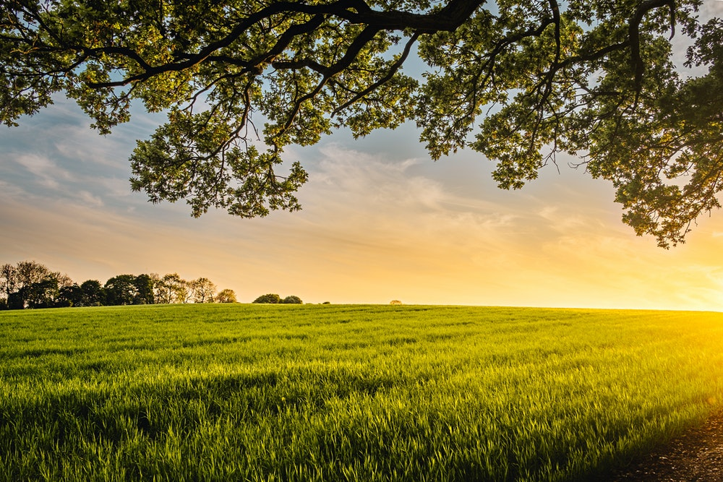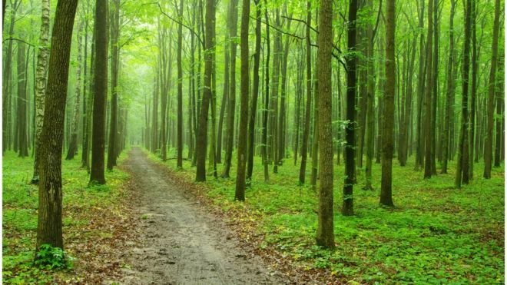Habitats Hunt

