
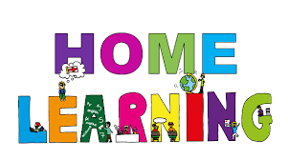
Pontarddulais Primary School
Home Learning
We will give you challenges based on this new topic, but all of the challenges will use skills that have already been taught to you in school. Use a workbook or your Hwb account and associated programs to complete your work. If you use Office 365, remember to share your work with your teacher. When using Just2Easy [J2e] remember to save your work for your teacher to see in your ‘My File Area’.
We hope you enjoy completing the challenges, we can’t wait to see the work you produce! Stay safe and take care – Mr Jones and Mrs Duquemin
Year Group: Year 4
AOLE | Week beginning Monday January 11th
Language Literacy and Communication | This week we are going to begin to look at the features of writing an instructional text. We will begin with looking at Imperative verbs or ‘bossy verbs’ as you might know them and adverbs.  Watch the video clips which you will find in the ‘Files’ section of teams or on the school website which will help you to understand how imperative verbs and adverbs are used. At the end of the videos there is a choice of 3 challenge work sheets to choose from which will help you apply and practice your skills.
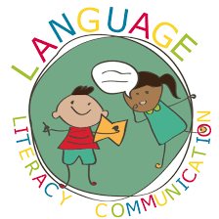
Health and Wellbeing | It is important to look after both our physical and mental wellbeing. Can you spend some time during the day doing any one of the following activities? Record how you were feeling before and after each activity. Do you think it makes a difference to how you are feeing during the day?  You can upload any photos and videos to Hwb.  - Read a book  - Find a comfortable place and listen to a piece of music of your choice  - Create and perform a dance to music  - Draw or colour a picture  - Go for a walk with someone in your home
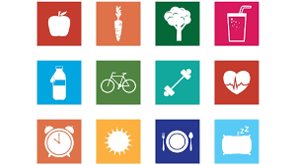

AOLE
Expressive Arts | Travel agents are closed at the moment due to the Pandemic. In Pontarddulais The Travel House is due to reopen later on in the year.  It will need a new name and a logo to attract people through its doors.  Can you think of a new name, logo and strap line for the re-opening.  Example  Bont Budget Travel  ‘Start in Bont, but the world’s your oyster’

Science and Technology | If you were to time travel to 2095, what might you find people travelling in, such as the type of cars, planes, trains etc? How would they look different? Would travelling be much faster? Would vehicles be more streamlined? Would cars be able to fly?  Can you plan, design and create a model of a futuristic form of travel that you might see in the future? You can use recycled materials, lego, knex etc.


AOLE
Mathematics and Numeracy | This week we are going to be learning about Multiplying.  There are 3 lessons in Maths this week and each lesson has the following:  - A video explaining how to complete the task  - A 1 star and a 2/3 star challenge sheet – You can either start with the 1 star and then have a go at the 2/3 star challenge or go straight to the 2/3 star challenge.  You will find the videos and challenges in ‘Files’ and then ‘Class materials’ in Teams and on the School Website.  Lesson 1: Multiply a 1-digit number by a 1-digit number – Drawing out the times table  Lesson 2: Multiply a 2-digit (teen number) by a 1-digit number – Splitting the 2-digit number into tens and units and then multiplying by the 1-digit number  Lesson 3: Multiply a larger 2-digit number by a 1-digit number – This is quite difficult. Have a go but do not worry if you struggle with this

Humanities | Choose a destination you would like to travel to. Research and create a fact file about that country. Use the following subheadings to complete the fact file:  Country:  Continent:  Capital:  Population:  Language:  Driving Side:  Flag:  Currency:  Distance from Swansea:  Famous People:



Article 28: You have the right to a good quality education and your education should help you use and develop your talents and abilities.

