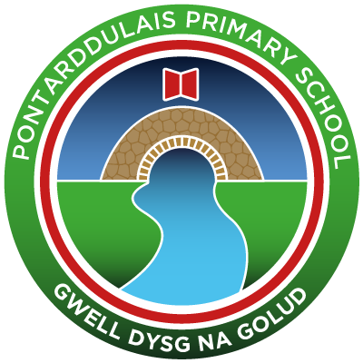
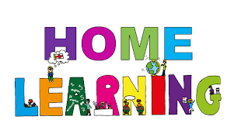
Pontarddulais Primary School
Home Learning
We will give you challenges based on this new topic, but all of the challenges will use skills that have already been taught to you in school. Use a workbook or your Hwb account and associated programs to complete your work. If you use Office 365, remember to share your work with your teacher. When using Just2Easy [J2e] remember to save your work for your teacher to see in your ‘My File Area’.
We hope you enjoy completing the challenges, we can’t wait to see the work you produce! Stay safe and take care – Mr Jones and Mrs Duquemin.
Year Group: Year 4
AOLE | Week Beginning Monday 18th January
Language Literacy and Communication | Like last week, there are 3 lessons in Language this week and each lesson has the following:  - A video explaining how to complete the task  - A 1 star and a 2/3 star challenge sheet  Last week we looked at the key features of instructional writing. For the first lesson this week, we would like you to write a set of instructions on how to pack a suitcase for your dream holiday!  Over 2 lessons, we will also be looking at how to make a boring sentence into an exciting sentence using nouns, verbs, adjectives and adverbs.
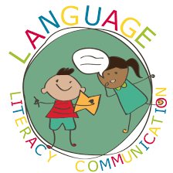
Health and Wellbeing | Whilst on holiday in a hot country, it is important to look after ourselves in the sun.  Can you create a poster outlining the dangers of the sun and think of some ways to keep safe from these dangers?  Try and make your poster as informative and eye-catching as possible! You can choose how you create your poster e.g J2E, paper etc.
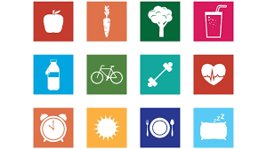

AOLE
Expressive Arts | Last week, you designed a new name, logo and strapline for The Travel House in Pontarddulais. This week, could you use these and create an advertisement for the new travel agents?  You can upload any photos and videos to Hwb.  You could make:  - An advert to go on TV  - A catchy song or jingle  - Music to go on an advert  - A leaflet to send out

Science and Technology | This week, we will learn about the organs that help our bodies to work. Follow the link to watch a video explaining what each organ does and why it is important: https://www.bbc.co.uk/bitesize/clips/zyqfg82  After you have watched the video, see if you can label the organs on the diagram, showing where they are found in the human body. You will find this diagram on the worksheet uploaded to the class folder. Try to do this on your own first – if you get stuck, there is a list of organ names in the folder that you can use to help you.  Next, on a piece of paper or on the computer, write one or two sentences to describe what job each organ does within the body. To help you with this, watch the video again and listen carefully to what the narrator says. You might also want to research the organs for yourself, using the internet with help from an adult at home.


AOLE
Mathematics and Numeracy | This week we are going to be learning about Dividing.  Like last week, there are 3 lessons in Maths this week and each lesson has the following:  - A video explaining how to complete the task  - A 1 star and a 2/3 star challenge sheet – You can either start with the 1 star and then have a go at the 2/3 star challenge or go straight to the 2/3 star challenge.  You will find the videos and challenges in ‘Files’ and then ‘Class materials’ in Teams and on the School Website.  Lesson 1: Divide a 2-digit number by a multiple of 2, 3, 4, 5 or 6 – Drawing out the division sum  Lesson 2: Divide a 2-digit number by a multiple of 2, 3, 4, 5 or 6 – Bus Stop Method  Lesson 3: Connections between Multiplication and Division – Know 1 fact, get 3 free!

Humanities | Over the next few weeks, we are going to be learning about a country called Botswana, in Africa. This week, we would like you to research Botswana and produce a factsheet with 10 interesting facts about the country. These facts could cover lots of different topics. For example, some things you might think about are:  • What traditions or festivals take place in Botswana?  • What is school like there?  • How is Botswana similar or different to Wales?  Think about how best to set out your factsheet. Make it as creative and eye-catching as you can! You might ask yourself:  • What colours could I use to make my factsheet look more interesting?  • Have I presented my facts in a clear and organised way? Will the person reading my factsheet be able to follow it easily?  • Do I want to include pictures or drawings? What pictures or drawings will best illustrate the facts that I have chosen?  Some links that may help you with your research on Botswana:  https://www.activityvillage.co.uk/botswana  https://kids.nationalgeographic.com/explore/countries/botswana/  https://www.ducksters.com/geography/country.php?country=Botswana  https://www.konnecthq.com/botswana-facts/
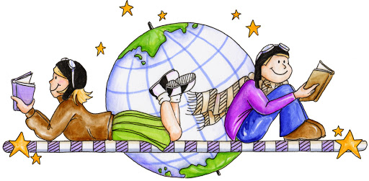

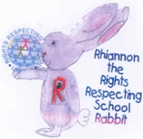
Article 28: You have the right to a good quality education and your education should help you use and develop your talents and abilities.

