Challenge 1
Below are some pictures, can you complete the sentences using the word bank on the power point so that they each include a noun, verb, adverb and 3 adjectives to make it an interesting sentence. You may have to think of your own words! Below is an example.
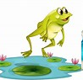
The frog jumped quickly into the clear, crystal, blue pond.

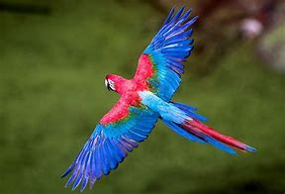

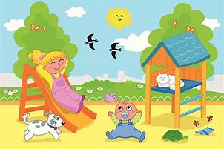
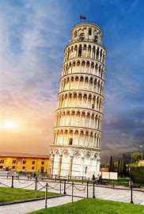

The Bird _____________________________________________
____________________________________________________
The Children ____________________________________
_________________________________________________
The tower____________________________________________
____________________________________________________
The ring ____________________________________________
____________________________________________________
The man ____________________________________________
____________________________________________________

