Challenge 2/3
Below are some pictures, can you complete the sentences so that they each include a noun, verb, adverb and 3 adjectives to make it an interesting sentence. You can use the grid below to help you plan what words to use.There is an example below.
Noun | Verb | Adverb | Adjective
Frog, pond | Jumped | Quickly | Clear, crystal, blue
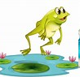
The frog jumped quickly into the clear, crystal, blue pond.

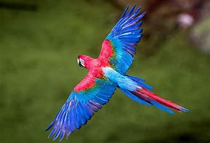
The Bird _____________________________________________
____________________________________________________

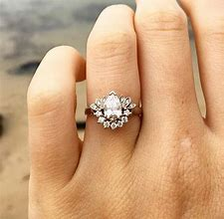
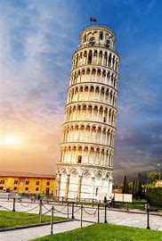
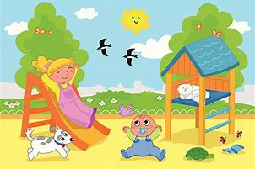
EXTENSION – Now write 10 of your own sentences to include all of the above grammar to make your sentences really exciting!
The man ________________________________________________
________________________________________________________
The ring _________________________________________________
________________________________________________________
The tower________________________________________________
_________________________________________________________
The Children _________________________________________
_____________________________________________________

