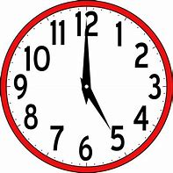
Challenge 1

Time Conjunctions

Task

Complete the following sentences by choosing a time conjunction from the box below. Make sure they make sense!

- She was in a bad car accident _________________she was young.

- We can’t play loud music _________________everyone has gone to bed.

- I’ll wait with you __________________________the bus arrives.

- I’ve been very busy _________________I started my new job.

- No one left the cinema _______________the movie was still on.

- We lived on a farm ______________________we were growing up.

- ______________we decided to go to Italy on holiday but then changed our minds.

- ________________we heard the sound of thunder.

- ______________________the waves came crashing around the boat.

- ________________________________I could hear the tiny baby cry.
when | just then | before | since | suddenly
just at that moment | in the beginning | until | while | without warning

