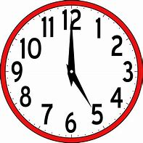
Challenge 2

Time Conjunctions

Task 1

Complete the following sentences by adding in a time conjunction into the sentences. Make sure they make sense! (Use the word mat on the power point to help you).

- She was in a bad car accident _________________she was young.

- We can’t play loud music _________________everyone has gone to bed.

- I’ll wait with you __________________________the bus arrives.

- I’ve been very busy _________________I started my new job.

- No one left the cinema _______________the movie was still on.

- We lived on a farm ______________________we were growing up.

- ______________we decided to go to Italy on holiday but then changed our minds.

- ________________we heard the sound of thunder.

- ______________________the waves came crashing around the boat.

- ________________________________I could hear the tiny baby cry.

Task 2

Use the time conjunction word mat on the power point to help you write 5 of your own sentences.

Examples: I finished my homework before I played outside.

Earlier, I had called my sister to come and play a game.

