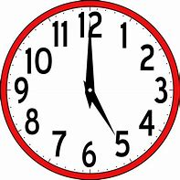
Challenge 3

Time Conjunctions

Task

Use the time conjunction word mat in the power point to help you write 10 sentences to include some of the time conjunctions.

Three examples are given below:
- She was in a bad car accident when she was young.

- Suddenly, the fireworks began popping and whizzing in the night sky

- Earlier, I had called my sister to come and play a game.

________________________________________________________________________________________________________________________________________________________________________________________________________________________________________________________________________________________________________________________________________________________________________________________________________________________________________________________________________________________________________________________________________________________________________________________________________________________________________________________________________________________________________________________________________________________________________________________________________________________________________________________________________________________________________________________________________________________________________________________________________________________________________________________________________________________________________________________________________________________________________________________________________________________________________________________________________________________________________________________________________________________________________________________________________________________________________________________________________________________________________________________________________________________________________________________________________________________________________________________________________________________________

