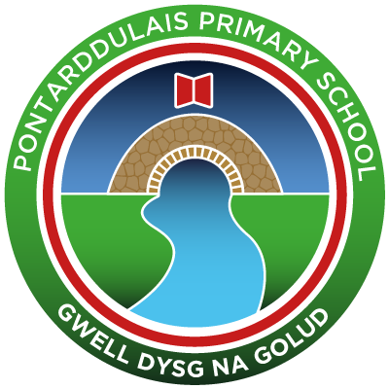
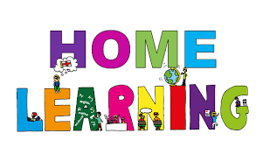
Pontarddulais Primary School
Home Learning
We will give you challenges based on this new topic, but all of the challenges will use skills that have already been taught to you in school. Use a workbook or your Hwb account and associated programs to complete your work. If you use Office 365, remember to share your work with your teacher. When using Just2Easy [J2e] remember to save your work for your teacher to see in your ‘My File Area’.
We hope you enjoy completing the challenges, we can’t wait to see the work you produce! Stay safe and take care – Mr Jones and Mrs Duquemin.
Year Group: Year 4
AOLE | Week Beginning Monday 25th January
Language Literacy and Communication | Like last week, there are 3 lessons in Language and each lesson has the following:  - A video explaining how to complete the task  - A 1 star and a 2/3 star challenge sheet  This week we will be exploring what a diary is, so that by the end of this week, you will have learned the skills you need to write a diary entry.  In lesson 1 you will learn how to use time conjunctions in sentences.  Lesson 2 is a lesson on when to use First and Third person in your writing.  Lesson 3 is where you will you use all the skills you have been learning! You will imagine you are on a fabulous dream holiday somewhere and you pop up to your hotel room at the end of a fun filled day and write a diary entry about the incredible things you have done that day.
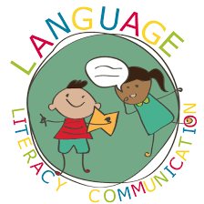
Health and Wellbeing | Botswana: Food  • Do you know what types of food people eat in Botswana? Read the document in the class materials file called ‘Botswana food specialties' to see some of the country’s most popular dishes.  • From what you’ve read, write a paragraph explaining whether or not you think the food in Botswana sounds healthy. Write about how eating healthy food makes you feel – try to include how this affects your brain as well as your body.  • Finish off your paragraph by comparing food in Botswana to the types of food that you regularly eat. Are they similar or different? Do you think you would enjoy eating Botswanan food? Why/why not?
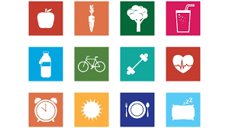

AOL
Expressive Arts | The Flag of Botswana  • Use the template in the class materials folder to create a piece of artwork inspired by the Botswana flag. Use the internet to find out the colours of the flag, then colour in the template using these colours.  • You can make your flag as creative as you like by using a variety of different techniques and materials. For example, you might want to use paints, or stick scrunched-up tissue paper onto your flag if you have these things at home. As long as you’ve used the correct colours, there is no right or wrong way to create your flag artwork – so feel free to experiment with whichever creative techniques or materials you like!  • Once your flag is ready, write or type a few sentences explaining what each of the colours in the flag represents. You can find this out by skim-reading the following webpage, which talks about the meaning of the Botswana flag: https://yourbotswana.com/2017/01/04/the-meaning-behind-the-botswana-flag/

Science and Technology | This week, we are going to be learning about our 5 senses. Can you research the 5 senses and write a few sentences explaining what job they do? To start, you could take a look at this video to help you: https://www.bbc.co.uk/bitesize/topics/z9yycdm/articles/zxy987h  You could also have a think about which sense you think is the most important and which sense you think is the least important. You could write a paragraph explaining which sense you think is the most important and the least important, and your reasons behind your decision


AOLE
Mathematics and Numeracy | This week we are going to be learning about finding the area of squares and rectangles and then a little bit of perimeter as well.  Like last week, there are 3 lessons in Maths this week and each lesson has the following:  - A video explaining how to complete the task  - A 1 star and a 2/3 star challenge sheet – You can either start with the 1 star and then have a go at the 2/3 star challenge or go straight to the 2/3 star challenge.  - Lesson 7: Finding the areas of rectangles and squares counting the squares  - Lesson 8: Finding the area of rectangles and squares using times tables  - Lesson 9: Finding the area and perimeter of rectangles and squares  You will find the videos and challenges in ‘Files’ and then ‘Class materials’ in Teams and on the School Website.

Humanities | Last week, you began learning about Botswana and created a fact file. This week, we want you to specifically focus on the culture in Botswana. Some things you could think about are:  · What is the main religion of Botswana?  · Do the people of Botswana wear a certain type of clothing?  · What type of music to the people in Botswana listen to? Do they have any special dances?  · In Botswana, what special events do they celebrate? Do they celebrate Christmas and Easter?  If you wanted to challenge yourself further, you could look at how the culture in Botswana compares to Wales. For example, instead of just talking about the religion in Botswana, you could say whether this is the same in Wales.  Your ideas can be presented in any way you want- a mind map, a poster, in a paragraph, in a leaflet. It is your choice!  An example will be uploaded to your Teams file to help you and here are some links which may also help you: · https://www.botswanatourism.co.bw/customs · https://www.ducksters.com/geography/country.php?country=Botswana · https://www.softschools.com/facts/countries/botswana_facts/2545/ · https://www.iexplore.com/articles/travel-guides/africa/botswana/festivals-and-events
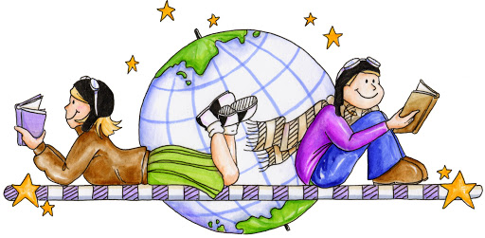

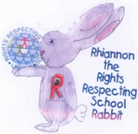
Article 28: You have the right to a good quality education and your education should help you use and develop your talents and abilities.

