How to use Google Maps to find how long it takes to travel between places:

1. Go to www.google.com/maps. Type the name of the place that you want to find in the search bar that says ‘Search Google Maps’, then press enter.

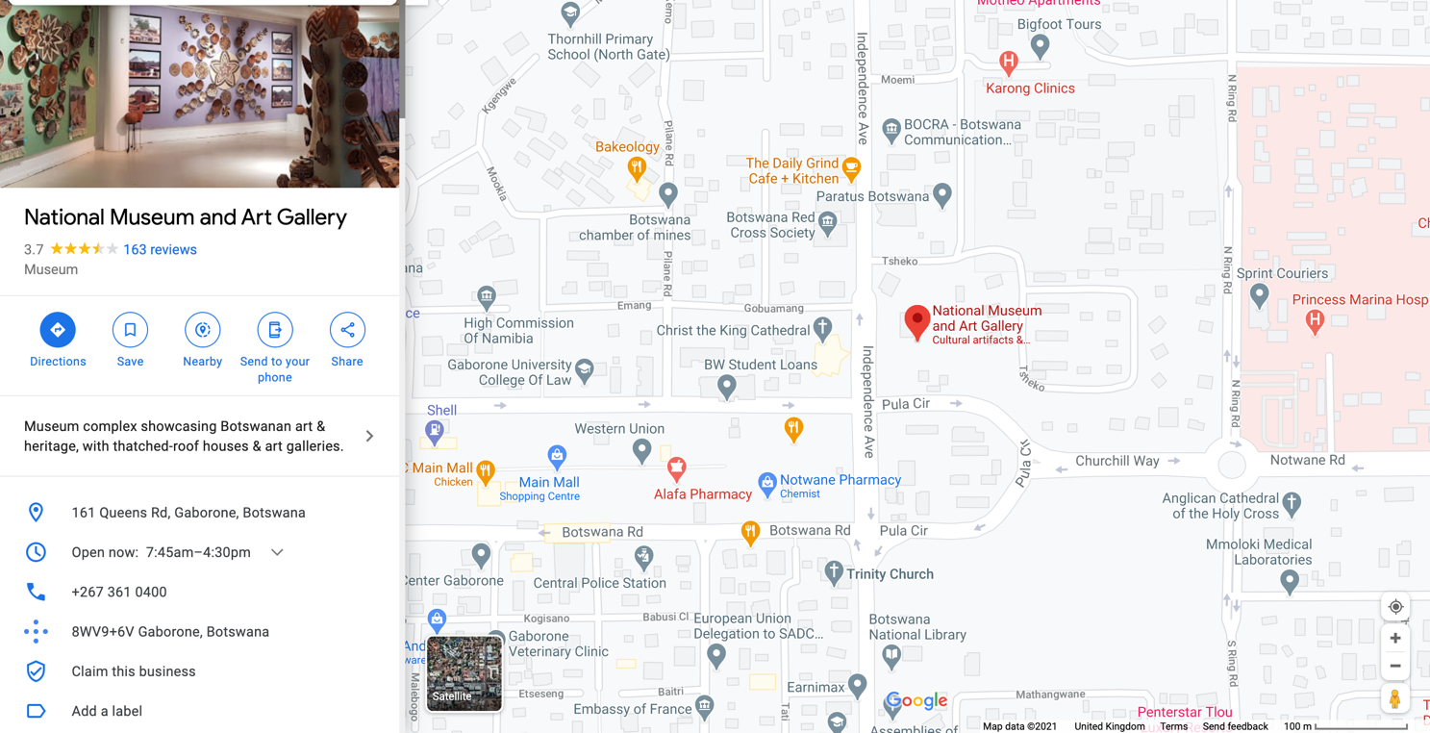
2. The red marker shows you where the place you’ve searched for is on the map.

3. Next, click on the button that says ‘Directions’.

4. Click on the button with two arrows pointing in opposite directions to make your destination the starting point.
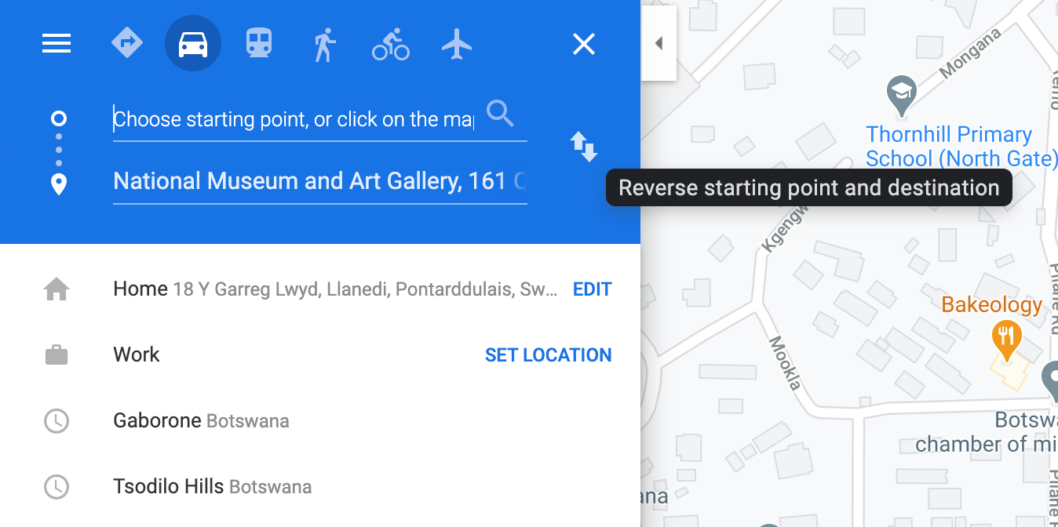

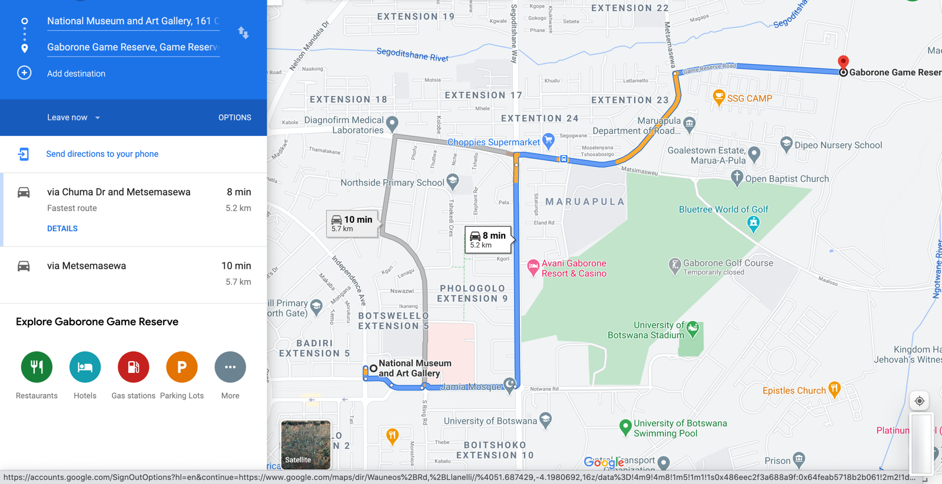
5. Type in your next destination in the box underneath.

6. Here, you can see how long it takes to get from one place to the next by car.

This particular journey shows you two different routes that lead to the same place – one is longer than the other by only a few minutes. Looking at these times, we could say that it would take roughly ten minutes to travel from the National Museum and Art Gallery in Gaborone to the Gaborone Game Reserve.

