Digital Time
Task: Match the analogue time to the digital time.

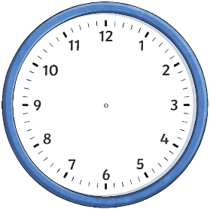
12:30
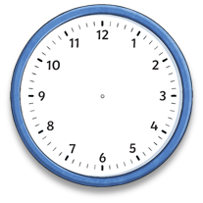
3:00
4:45
2:15
10:45

Can you write these two analogue clocks in digital time? Can you also say whether it is A.M. or P.M.? (You can decide)


 

