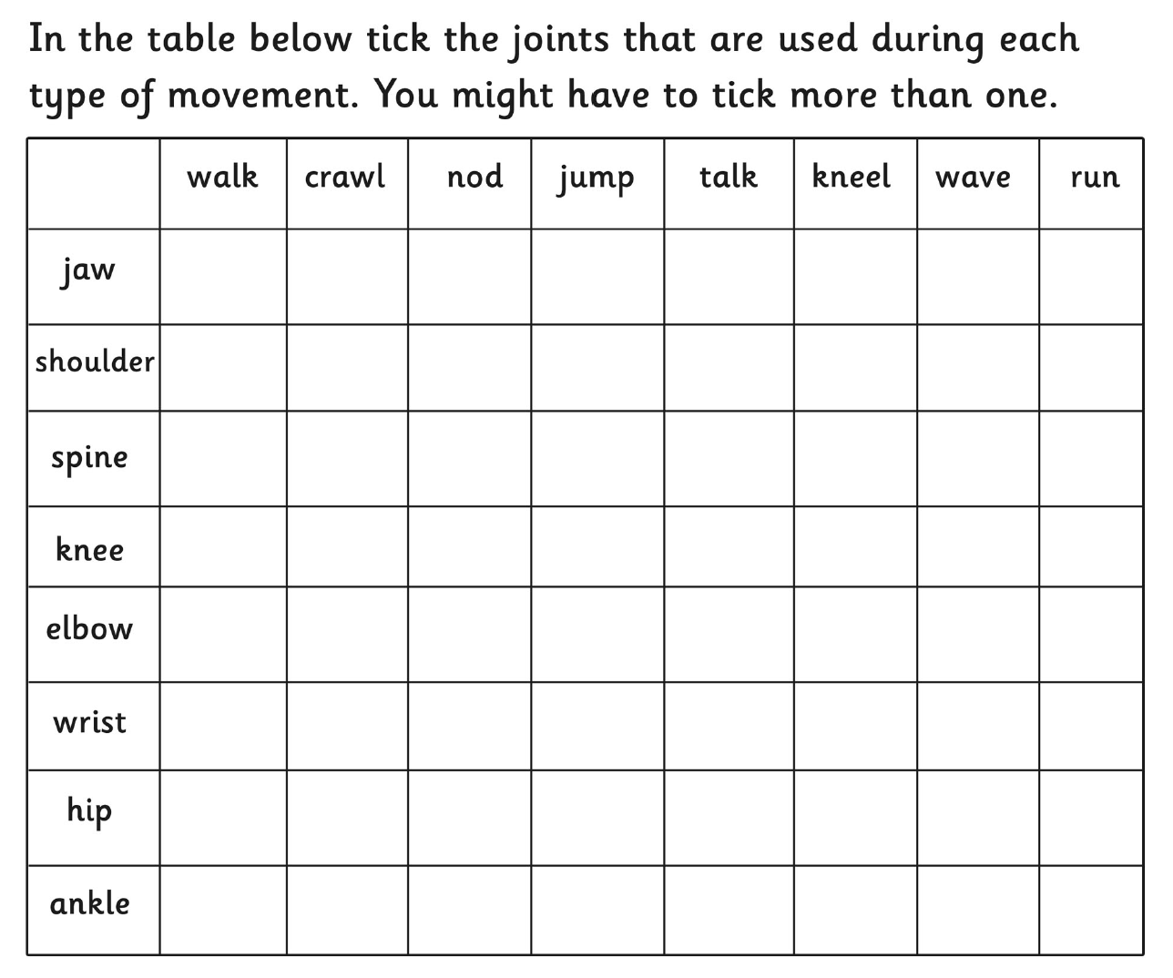

Which joint/joints did you use the most in this enquiry? Why do you think this is?

_______________________________________________________________________________________________________________________________________________________________________________________________________________________________________________________________________________________________________________________________________

