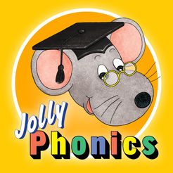
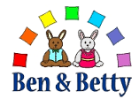
All about ‘a’’
This weeks special friends are Adam, Aiden, Alfie, Alfie and Abigail
During the next week, Nursery will take part in lots of activities that will immerse them into the sound ‘a’ following the phonic programmes Ben and Betty and Jolly Phonics.
They will;
- make apple crumble
- play in an ambulance role play area
- take part in apple rolling
- learn a welsh song about the weather (this can be found on our school website)
- talk about feeling angry
- measuring big and small ants
- listening to animal noises and matching them to the animal
- following arrows
- build animal habitats
- take part in an archaeological dig
Please remember to bring any labelled objects from your home that begins with the sound of the week for show and tell on a Monday.
Can you please spend some time listening to the Jolly Phonics sounds on youtube, the children love repeating the actions and rhymes. Type in ‘jolly phonics a’ into the YouTube search bar, or look on our school website.
The rhyme of the week is the ‘Ants go Marching One by One’ maybe your child would like to sing it to you at home.
Important notice
The special activity this week is animal face painting and eating apple crumble, please let us know Monday morning if you do not want your child to take part in the activity.
Dates for the Diary
Teddy Bears Birthday Party- Wednesday 2nd of September at 11.00
Bont Festival- Tuesday 5th of November at 11.00

Thank you for your continued support,
Nursery Team


