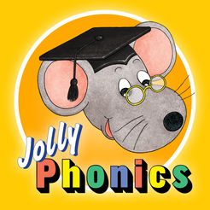

All about ‘d’

During the next week, Nursery will take part in lots of activities that will immerse them into the sound ‘d’ following the phonic programmes Ben and Betty and Jolly Phonics.
They will;

- Playing in a doctor role-play
- Building dens outdoors (we would be very grateful for old bedsheets you no longer want)
- Planting daffodils
- Taking part in a dough disco
- Disco dancing
- Reading ‘Dear Zoo’
- Dapping dots on the letter d
- Learning our colours in welsh
- Counting drum beats and finding the matching numicon 1, 2 and 3

The children love taking part in dough discos, why not try one at home? You can find the video on our school website.

Homework
Can your children remember and recognise a,b,c,and d? It really helps to put these letters up around the house and to keep interacting with them everyday.
Here are some number formation rhymes to help at home:

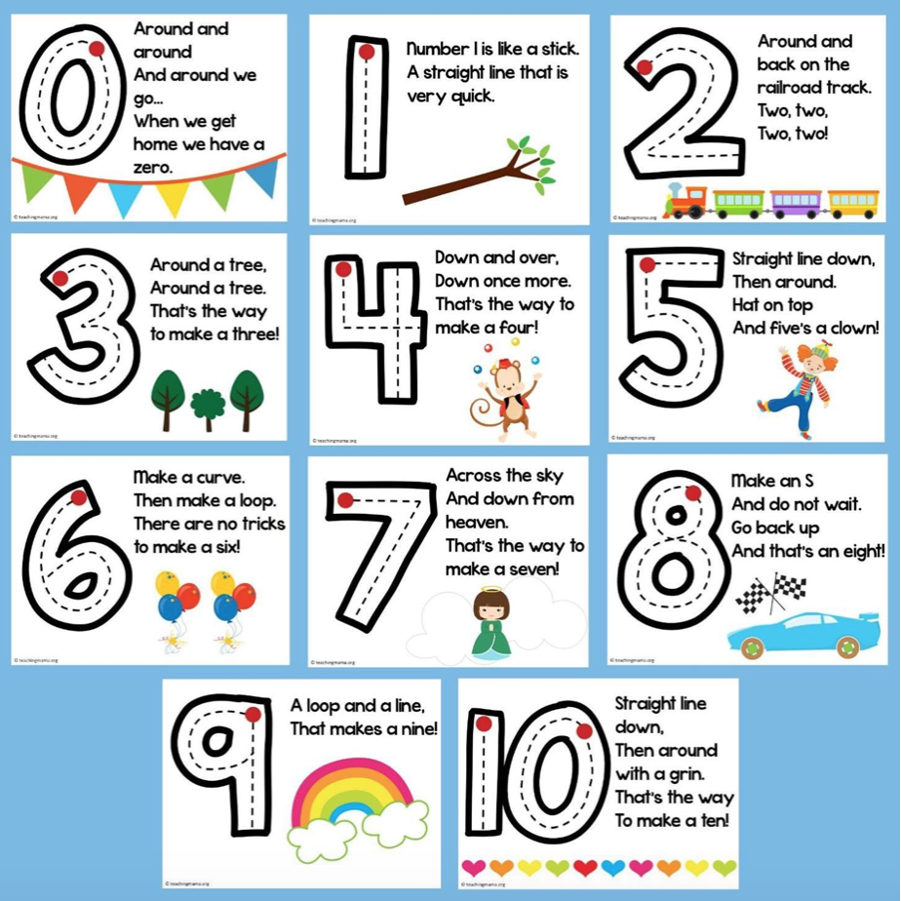

Dates for the Diary
Bont Festival- Tuesday 5th of November- we are looking forward to seeing you. Christmas concert will be on Wednesday the 4th of December.

Thank you for your continued support,
Nursery Team


