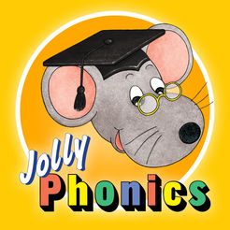
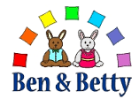
All about ‘e’
This weeks special friends are: Esumanur and Ella
During the next week, Nursery will take part in lots of activities that will immerse them into the sound ‘e’ following the phonic programmes Ben and Betty and Jolly Phonics.
They will;
- Play in the water using the words empty and full
- Write the letter e and fold it into an envelope
- Collage pictures of Elma
- Take part in egg and spoon races
- Practice writing the number 3 in sand, paint, shaving foam and glitter
- Learn colours in Welsh
- Make elf hats
- Find Elves and Fairies in the forest
The story of the week is going to be Elma

Please remember to bring any labelled objects from your home that begins with the sound of the week for show and tell on a Monday.
Can you please spend some time listening to the Jolly Phonics sounds on youtube, the children love repeating the actions and rhymes. Type in ‘jolly phonics into the YouTube search bar.

Important notice
We will soon be giving out parts for the Nativity Christmas Concert, please let us know on Monday if you would not like your child to take part for religious reasons.
Homework
Elma is a very special elephant who is different in lots of different ways, can you name all they ways you are special at home.
Dates for the Diary
Bont Festival- Tuesday 5th of November
Christmas concert will be on Wednesday the 4th of December.
Thank you for your continued support,
Nursery Team


